Registering as a New Online User
If you are a first-time user, you will need to register for a new account. Please click on the register link.
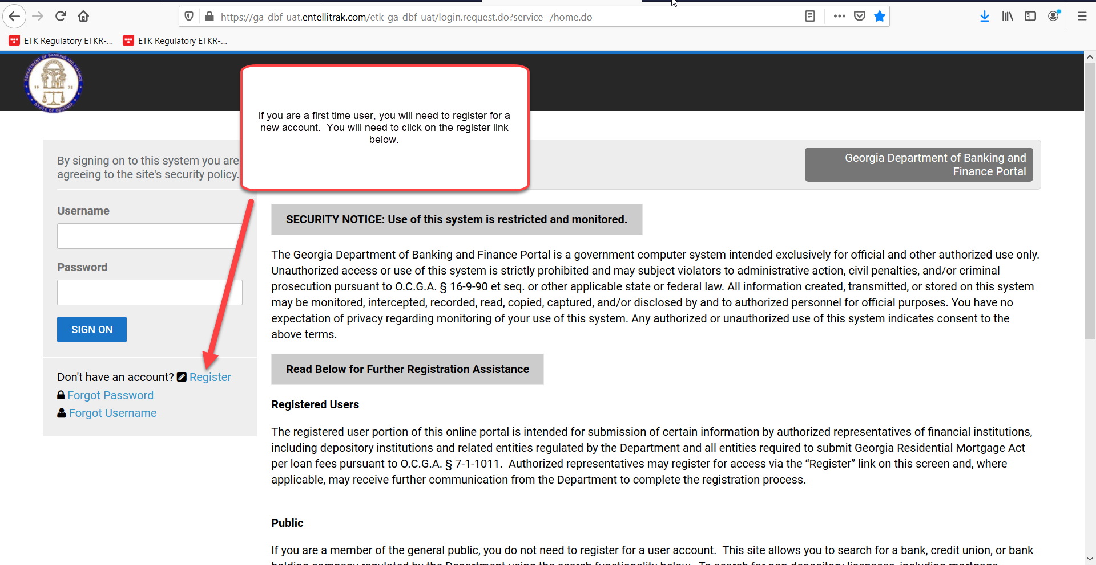

Once you click on register, you will be asked to provide the following required information:
First Name
Last Name
Username – This is a username that you will create.
Email Address
Confirm Email Address

Once you have provided the above information, you will need to click register.
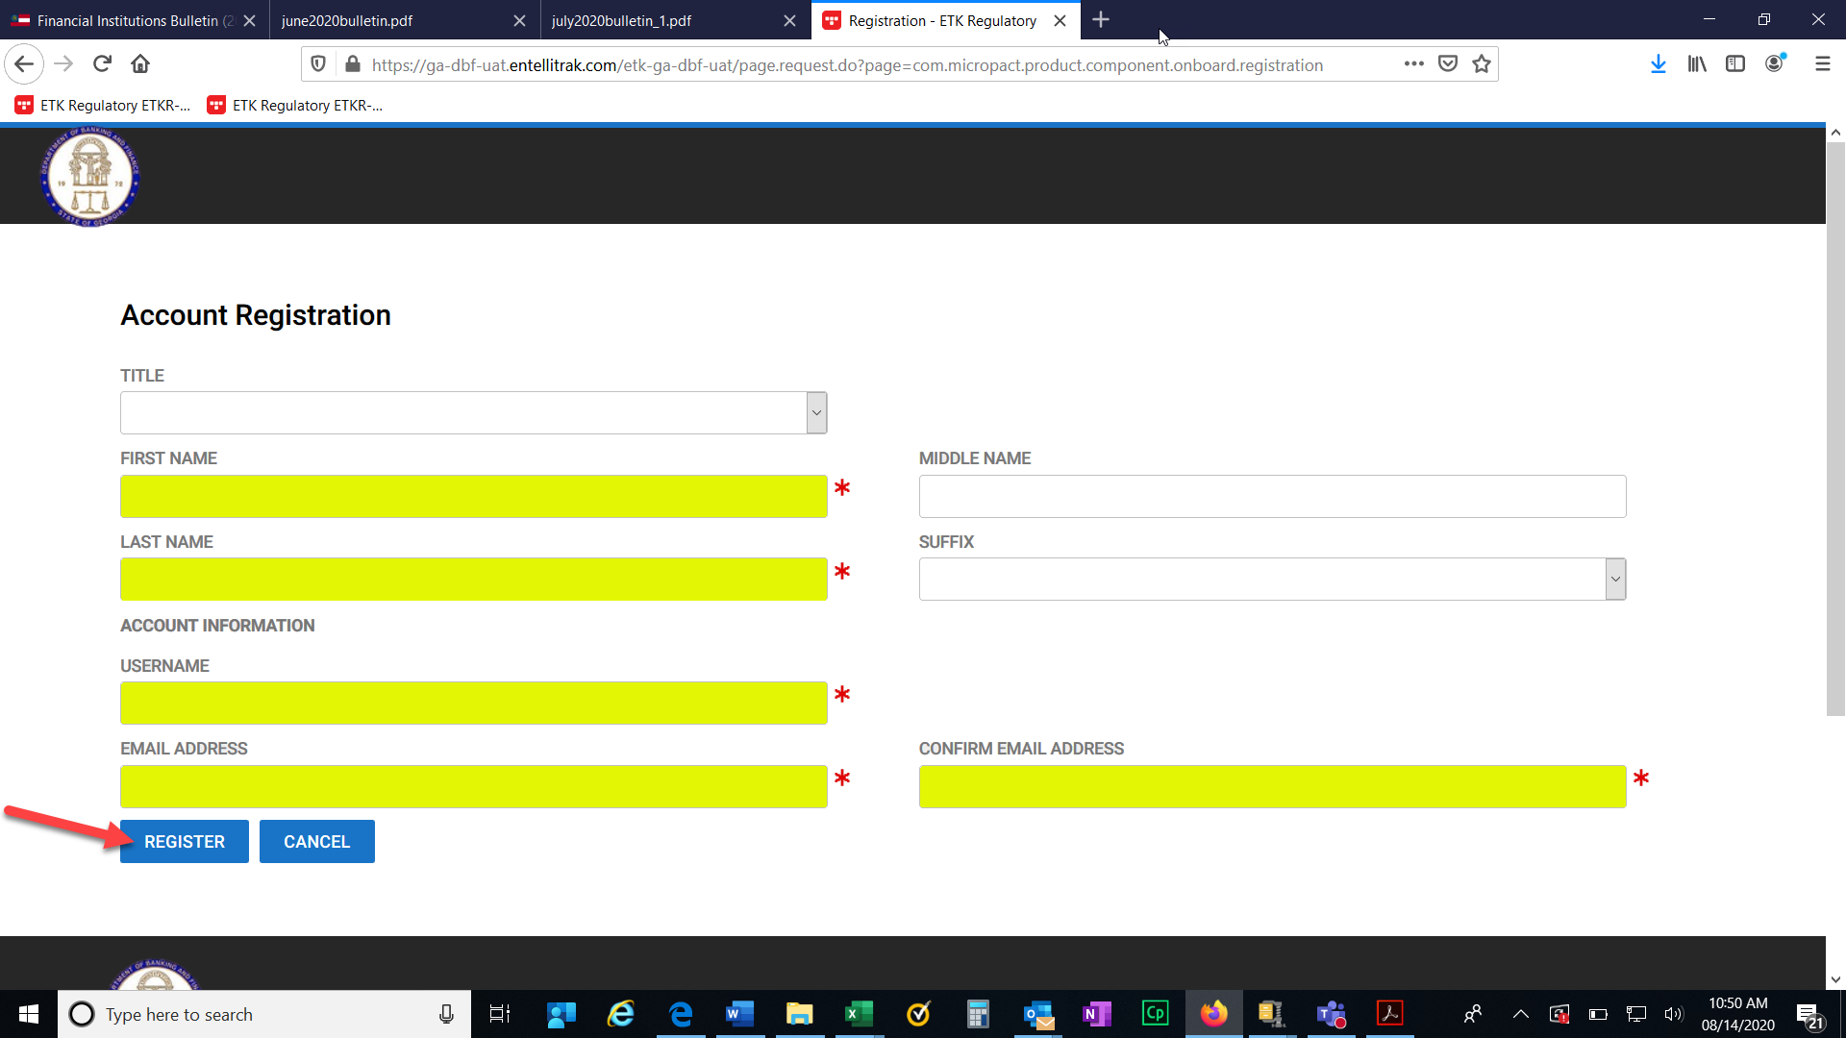

After clicking register, you should receive a confirmation screen that will allow you to return to login. You will need to check your email for the temporary password that will be sent to you in order to login to the system.
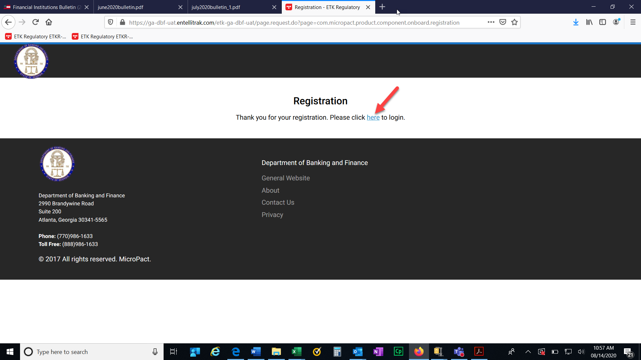

Once you click the link to login, you will need to provide your username and temporary password. Then click Sign On.
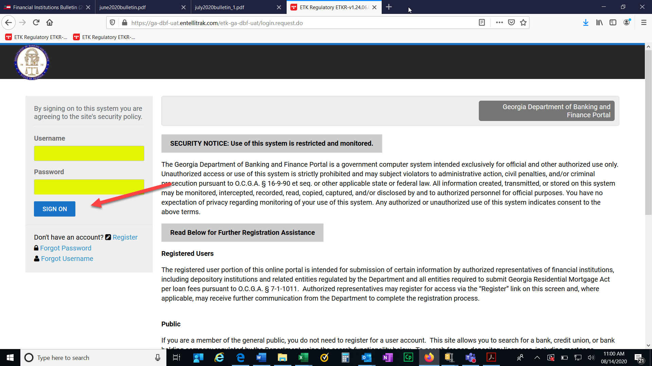

Paying Your GRMA Submission
Next you will need to provide your GRMA submission. You will scroll down until you see the applications and other requests section. Click on View transactions.
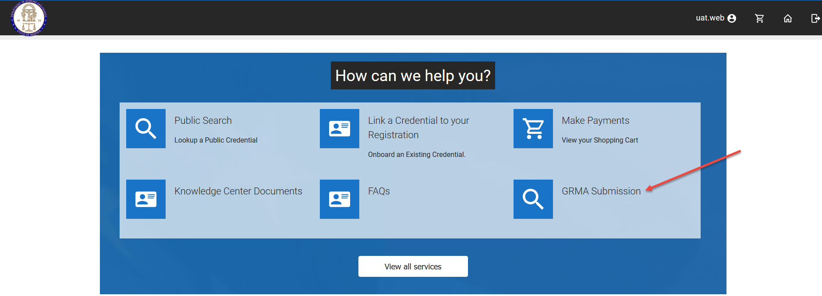

You will need to enter your NMLS number and click search.

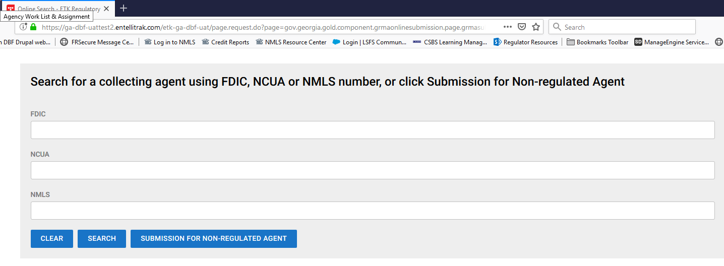

For regulated entities, you should see the entity that corresponds to the NMLS number that you submitted. Click select and submit for the approved selection.

You will need to review the instructions on the screen and then click next.
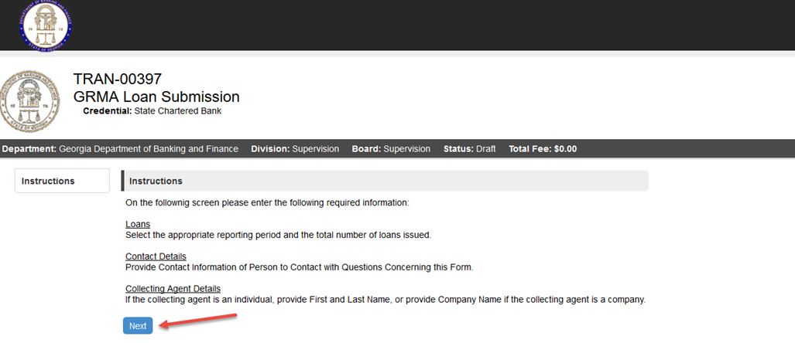

The items highlighted are required. All other information is optional. Then click Next.
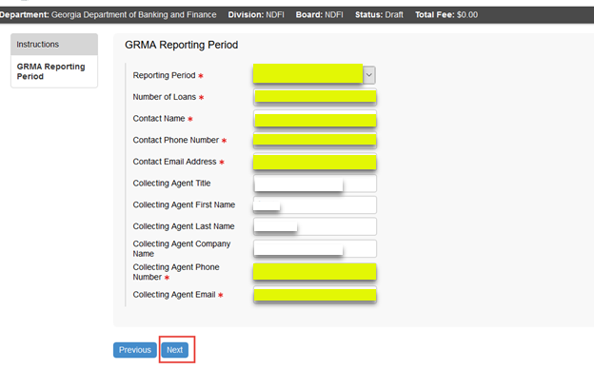

Please review the following statement. When you submit the information to us, you are attesting that it is true and correct to the best of your knowledge. You will not be able to move forward if you click no. You will need to contact the Department directly. Once you select yes, then click next to proceed.
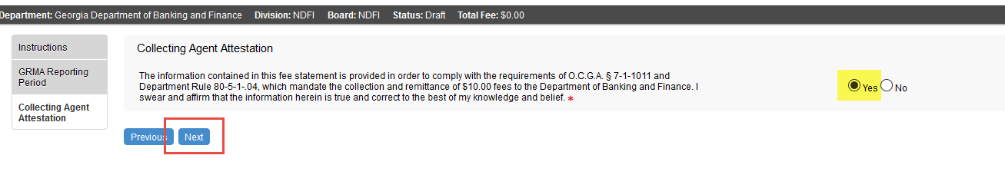
Once you click next, you will have an opportunity to review the information that you inputted prior to submitting your GRMA Submission and paying. Once you click add to cart, you will not be able to make any changes to the transaction.
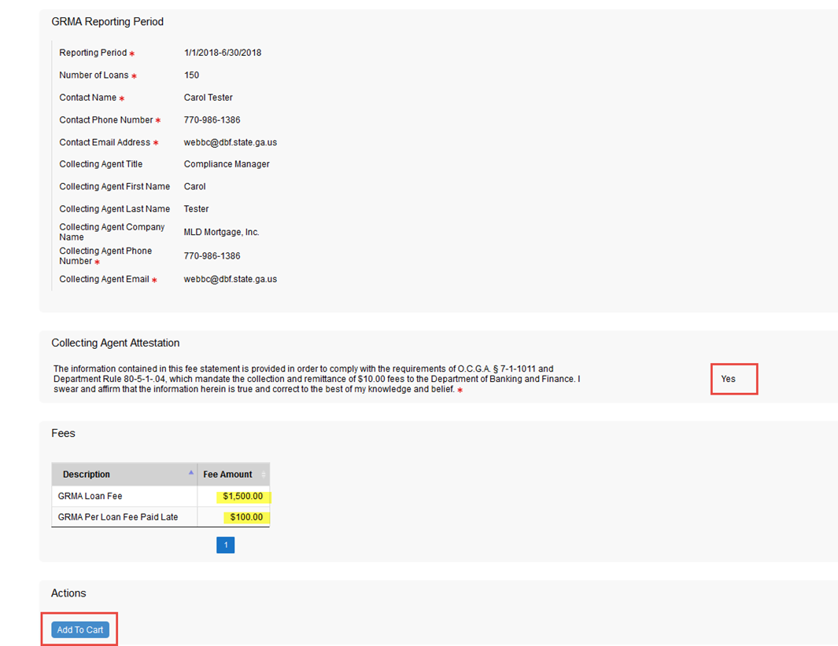

Once you click Add to Cart, you will receive a thank you message at the bottom of the page Please click on the here link to submit your payment.
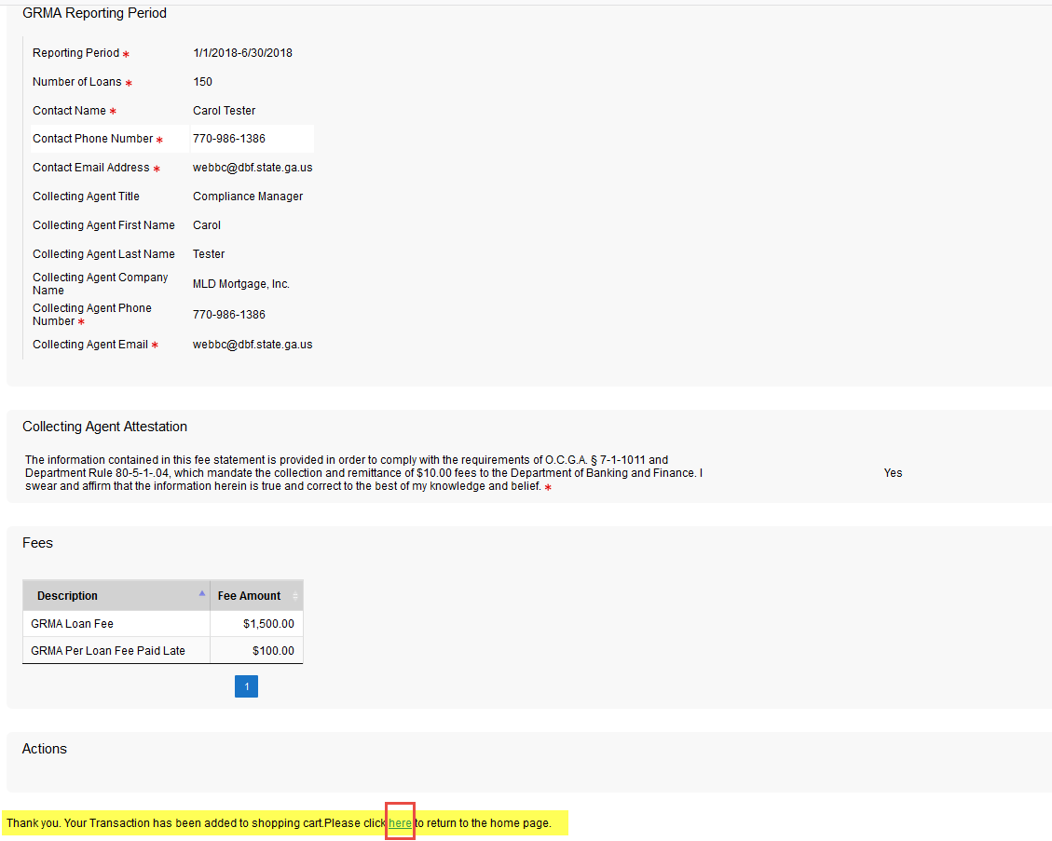

Click on the shopping cart at the top of the page.

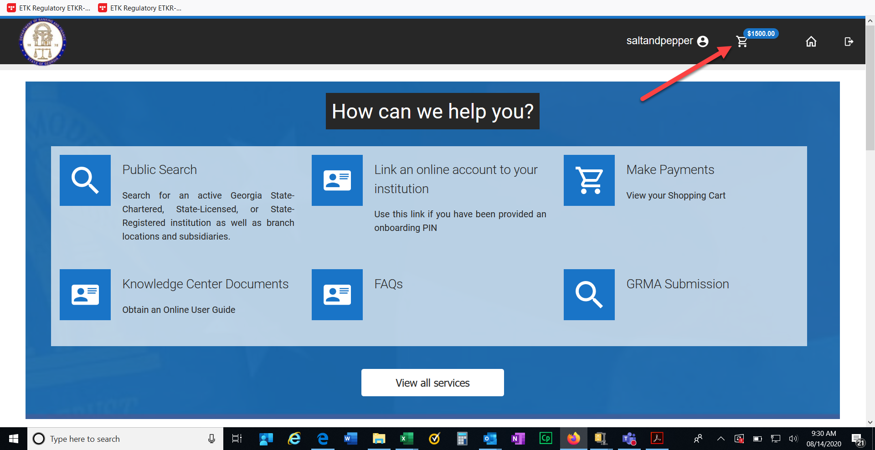

This screen will show you the amount that you owe. Click Submit Cart.
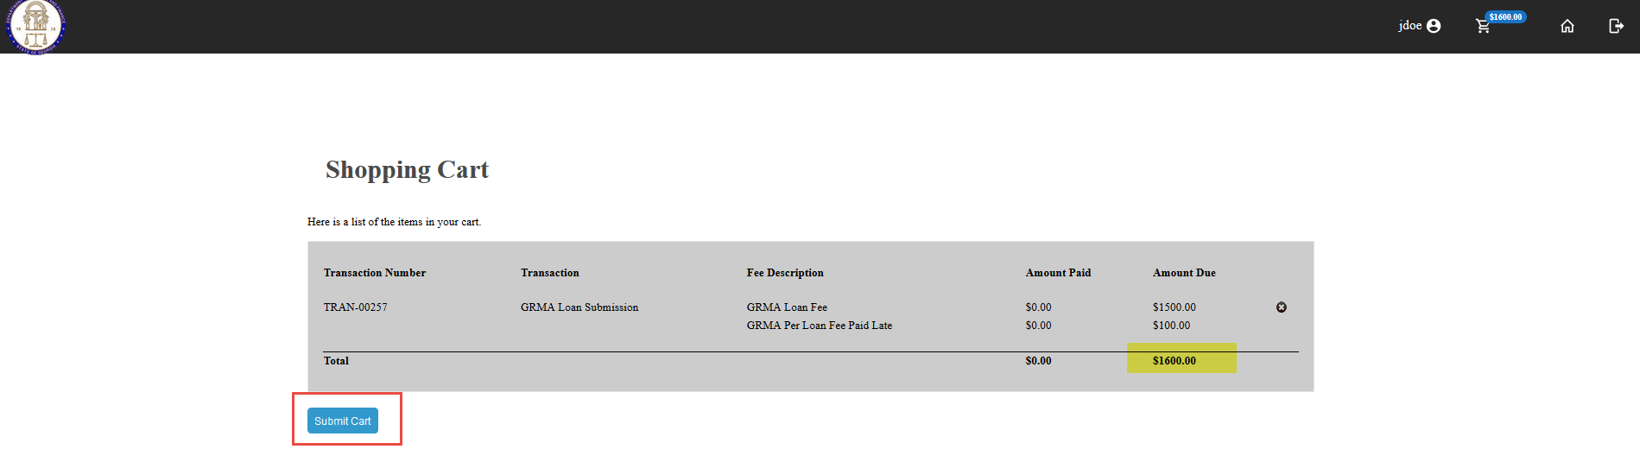

The next screen will take you to our payment site. You can choose to pay by check or credit card.
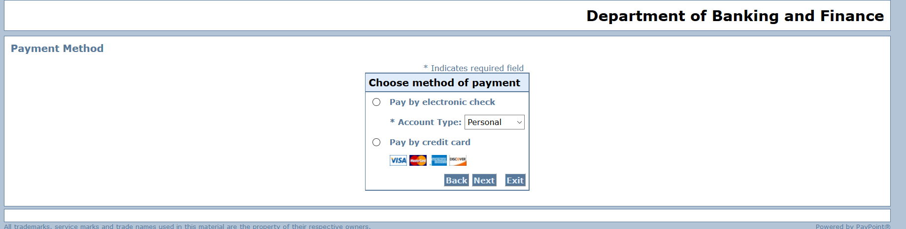

Please complete the required fields for a credit card payment. These fields are highlighted below. Then click Next.
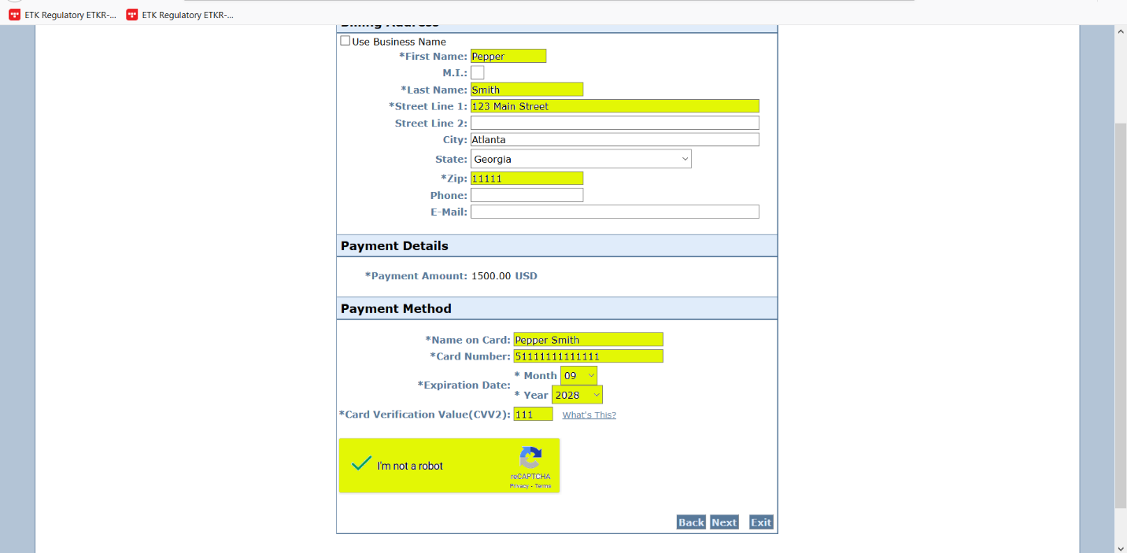

Please complete the required fields for a check payment. These fields are highlighted below. Then click Next.
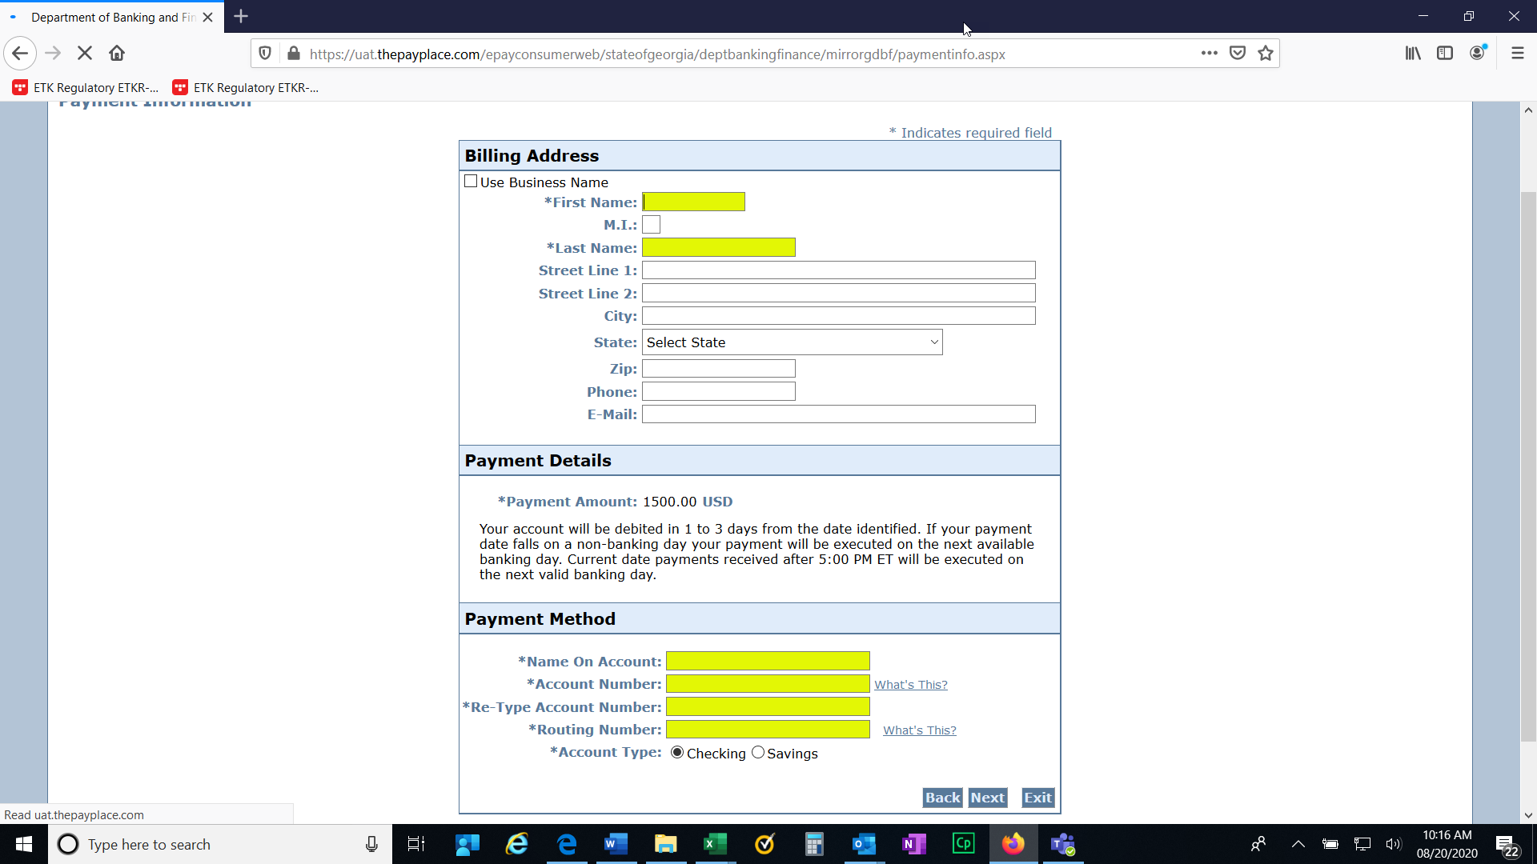

The next screen will be a confirmation of the information that you just entered along with the amount that you are paying. Click Pay now.
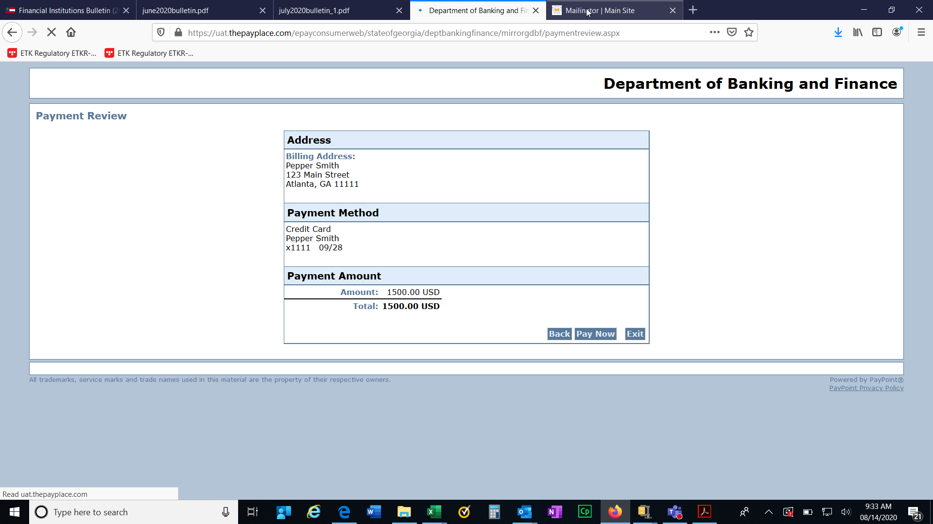

Once your payment processed, you will receive a payment successful screen. You have now completed the online payment. You may log out of the system.
